1. **Introduction**

Our Blood Management application helps the users to find the donor for a particular blood group in a particular location in the easiest way possible. All the donors who wish to donate blood are supposed to enter their details in the application. The details include their Name, Age, Contact number, Email ID, Location (ZIP Code) and most importantly their blood group. The recipients who wish to receive blood should login to the application with their mobile number and are supposed to search the forum based on the required blood group and the location, they can contact the donor for further details.

The project has been divided into four phases with improving implementation features. For the first iteration of our project we want to complete all design section of the application with Login, Registration, Home page designs. We have chosen the android platform to develop our application. For this first phase, we have designed the UML Class diagram, Sequence diagram, State diagrams along with wireframes. We concentrated mainly on the design part which play a major role in implementing our project.

1. **Functions**
   1. **Login**

Login Page lets the user login to the application. User needs to enter the Username and Password in order to login. If the user doesn’t have an account to Login, he should register first.

**2.2 Register**

Register page lets the user to register. User needs to provide personal information to create an account.

**2.3 Home**

In Home Page, already registered user details like Name, Zip Code, Contact Numbers are displayed.

* 1. **Search**

Once the user registers, all his personal information is stored in SQLite database. User who needs blood should login into the application and search based on the blood group and Zip code and he can then contact the donor based on the contact information present in the application.

* 1. **Admin**

Users can anytime contact Admin for emergency situations. If any of the contact details or the Blood Group is different from what is required, Admin helps the user for more information.

1. **Proposed System**

1. Requirement Specification:

• Functional Requirements:

1. User should have a Sign in.
2. If user is new, he should have a Register.
3. User should be able to provide his personal information.
4. User details should be valid.
5. User should be able to search based on the Blood Group.
6. User should be able to search based on the Zip Code.
7. User should be able to view the corresponding contact details.
8. User should be able to contact the Admin in emergency situations.
9. User should be able to contact the donor whose details user found on the application.
10. User should be able to close the session.
11. User should be able to logout.
12. **Technologies Used**
13. ADT: Android Studio
14. Programming language: JAVA
15. Database: SQLite
16. Frontend: XML, JavaScript
17. **Development**

**System Designs:**

1. Login: Allow users to login into their account. Users use email address and Password to identify themselves.
2. Registration: Allow new users to create an account. User information collected during this process:
   * First name
   * Last name
   * Date of birth
   * Email address
   * Password
   * Blood Type
   * Zip Code
   * Mobile Number
   * Gender
3. Logout: Allow users to logout of their account
4. Registration validation: All fields should be valid.
5. Blood donation: The registration form takes the blood group of the user while registering. The entered value should be a valid blood type. It’s a drop down system where the user needs to select one of the available blood types. The user should have a valid email ID and a Mobile Number.
6. Contacts display: Once the user enters the blood group he wants, he gets a list of all the corresponding blood types and all the contact details

**UIs:**

1. Login UI: Implement login activity UI design
2. Register UI: Implement register activity UI design
3. Search UI: Implement search activity UI design
4. Blood Group Selection UI: Implement Blood group activity UI design
5. Donor Details UI: Implement Donor details UI design

The below picture illustrates the specific ways in which blood can be donated.

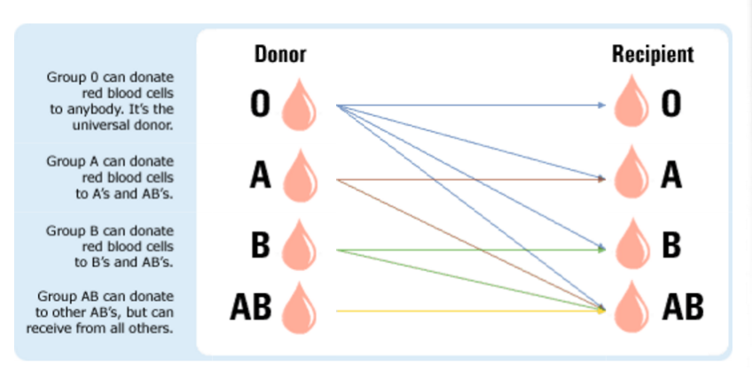

**Explanation:**

* Donors with blood type O can donate blood to Recipients with blood groups O, A, B, AB. That’s why people with blood group O are called Universal Donors.
* Donors with blood type A can donate blood to Recipients with blood groups A, AB.
* Donors with blood type B can donate blood to Recipients with blood groups B, AB.
* Donors with blood type AB can donate blood to Recipients with blood group AB. People with blood type AB can receive blood from all the other blood types. That’s why they are called the Universal Recipients.

With the above observations, whenever a user wants a particular type of blood, he gets all the blood types who can donate blood to that required type not just the same blood type which the user entered. According to the above algorithm, the user has a bigger platform than just getting one single blood type. He gets to see a higher number of donor information and the probability of the correct match is higher. This improvises the typical blood donation system.